CS C002 Programming Project

* **Name**

Jane

* **Title:**

2048 game

* **Description:**

2048 is a single-player sliding block puzzle game. The game's objective is to slide numbered tiles on a grid to combine them to create a tile with the number 2048.

It is played on a gray 4×4 grid, with numbered tiles that slide smoothly when a player moves them using the four arrow keys，← ↑ → ↓.

Every turn, a new tile will randomly appear in an empty spot on the board with a value of either 2 or 4.

Tiles slide as far as possible in the chosen direction until they are stopped by either another tile or the edge of the grid. If two tiles of the same number collide while moving, they will merge into a tile with the total value of the two tiles that collided.

The resulting tile cannot merge with another tile again in the same move.

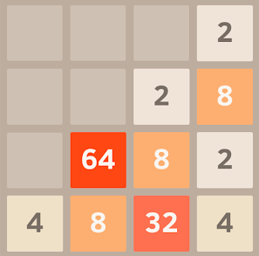

* **Reason:**

By inspired by the tic-tac game, I want to write a game which display a new board once the player chooses a move. In tic-tac game, the move is a cell number, and in 2048 is a direction. The 2048 game is very popular in last two years and I played it with my friends for a long time. The game is originally written by JavaScript and CSS, and I want to try the C version.